**Name : Ahmed Ibrahem Salem Ahmed Elgafary**

**Group : 1**

**Section : 1**

**B**.N : 22

Date : 4-6-2021

Topic : Internet OF Things

Application Brief :

IoT wants to connect all potential objects to interact each other on the internet to provide secure, comfort life for human. Internet of Things (IoT) makes our world as possible as connected together. ... Embedded computing devices would be exposed to internet influence .

Screenshots :

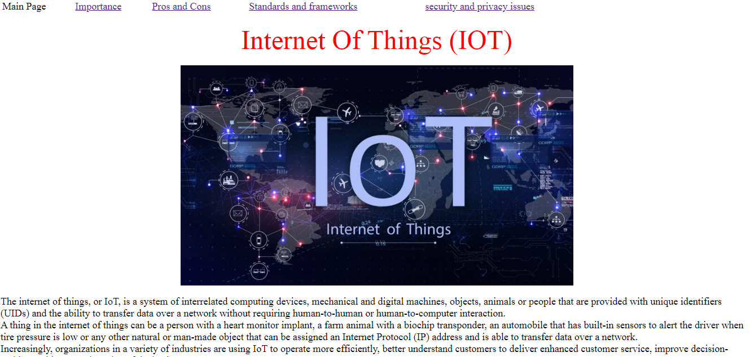

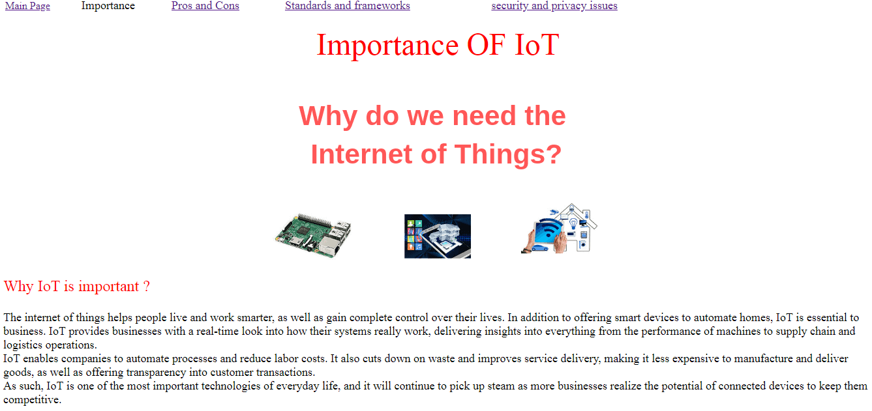

Source Code :

